Assignment-I

Case study: Before coding of the website, planning is important, students should visit different websites (Min. 5) for the different client projects and note down the evaluation results for these websites, either good website or bad website in following format:
Sr. No. | Website URL | Purpose of Website | Things liked in the website | Things disliked in the website | Overall evaluation of the website (Good/Bad)

From the evaluation, students should learn and conclude different website design issues, which should be considered while developing a website.

Assignemnt-II
Title: Implement a web page index.htm for any client website (e.g. a restaurant website project) using following:
a. HTML syntax: heading tags, basic tags & attributes, frames, tables, images, lists, links for text & images, forms etc.
b. Use of Internal CSS, Inline CSS, External CSS
HTML Elements
1. Frames
By Using frames, we can divide the display screen into multiple scrolling sections, each of which can display a different web page on it. Therefore It allows multiple HTML documents to be seen concurrently.
Tags use to add frames are given below.
Tag : <frameset> </frameset>
Description : Splits browser screen into frames.
Attributes : Rows=number helps in dividing the browser screen into horizontal sections or frames. Cols=number divides the screen display into vertical sections or frames. Hence, The numbers write in rows and columns attribute can be given as absolute numbers or percentage value or an asterisk(*) can be used to indicate the remaining space.
Example :
1
<html>
2
<frameset rows = “20%, 3
30%, *”>
4
</html>
Tag :<frame> </frame>
Description: used to define a single frame in a <frameset>
Attributes: name=text Assigns a name to the frame no resize Prevents the users from resizing
the frame. src=url Specifies the location of the initial HTML Document to be display by the frame.
Although bordercolor=”#rrggbb” or color name Sets the color for frame’s borders Example :
1
<html>
2
<frameset rows = "50%, *">
3
<frameset cols = "50%, *">
4
<frame src = "success.html" name = "frm1"> 5
<frame src = welcome.html" name = "frm2"> 6
</frameset>
7
<frame src = "failure.html" name = "frm3"> 8
</frameset>
9
</html>
2. Tables
A table is a two-dimensional matrix, consisting of rows and columns. HTML tables are intend to display data in the columns on a web page.Thus the Tables contain information such as text, images, forms, hyperlinks, etc.
Tags use to create the table are given below.
Tag : <table> </table>
Description : Create a table
Attributes: Border=number Draws an outline around the table rows and cells of width equal to
the number. By default, the table has no border number =0. Width=number Defines the width of the table.
Hence, Cellspacing=number Set the amount of cell space between table cells. Thus, the default value is 2
Cellpadding=number Sets the amount of cell space, in a number of pixels between the cell border and its contents. The default value is 2
Cellpadding=number Sets the amount of cell space, in a number of pixels between the cell border and its contents. However, Default is 2
Bgcolor=”#rrggbb” sets background color of the table Bordercolor=”#rrggbb” sets border color of the table align=left | right | center
Aligns the table. Since the default alignment is left frame=void | above | below | hsides | lhs | rhs | vsides | box | border
Therefore, the browser where to draw borders around the table
Tag : <tr> </tr>
Description: Creates a row in the table
Tag : <th> </th>
Description : Cells are insert in a row of the table for heading
Tag : <td> </td>
Description: Data cells are insert in a row of the table
01
<html>
02
<title>
03
<head>Table
04
</head></title>
05
<body>
06
<table border = 2 cellspacing = 4 cellpadding = 4 bordercolordark = "red" bordercolorlight = "blue" a07
<caption> List of Books </caption>
08
<tr>
09
<th rowspan = 2 align = "center"> Item No </th>
10
<th rowspan = 2 align = "center"> Item Name </th>
11
<th align = "center" colspan = 2> Price </th>
12
</tr>
13
<tr>
14
<th align = "center"> Rs. </th>
15
<th align = "center"> Paise </th>
16
</tr>
17
<tr>
18
<td align = "center"> 1 </td>
19
<td align = "center"> Programming in C++ </td>
20
<td align = "center"> 500 </td>
21
<td align = "center"> 50 </td>
22
</tr>
23
<tr>
24
<td align = "center"> 2 </td>
25
<td align = "center"> Programming in Java </td>
26
<td align = "center"> 345 </td>
27
<td align = "center"> 00 </td>
28
</tr>
29
</table>
30
</body>
31
</html>
3. Images
Tag : <img src="filename.extension"></img>
Attributes :
∙ Use the HTML src attribute to define the URL of the image
∙ Use the HTML alt attribute to define an alternate text for an image, if it cannot be displayed
∙ Use the HTML width and height attributes or the CSS width and height properties to define the size of the image
∙ Use the CSS float property to let the image float to the left or to the right
Example :
1. <!Doctype Html>
2. <Html>
3. <Head>
4. <Title>
5. Insert an Image
6. </Title>
7. </Head>
8. <Body>
9. Hello JavaTpoint! <br>
10. <img src="https://image3.mouthshut.com/images/ImagesR/imageuser_m/2017/11/92 5747536-4559193-1.png?rnd=38062" width="400" height="200"> <br> 11. Hello User! <br>
12. How are You?
13. </Body>
14. </Html>
4. Lists
Lists are a great way to provide information in a structured and easy-to-read format. There are two types of lists :
1. Number List (Order List): An order list is used when the sequence of list items is important.
2. Bullet List (Unorder List): An unorder list is a collection of related items that have no special order or sequence or series. Therefore tags use to create lists are given below.
Tag : <li>
Description : Specify the list item.
Tag : <ol> </ol>
Description: The <ol> tag formats the contents of an ordered list with numbers. Hence the number starts with 1. It is increment by one for each successive order list item tag with <li>
Attributes : Type = a / A / i / I / 1 Set the numbering style to a , A , i , I,1 default is 1 start = “A” Specifies the number or letter which in the list should start.
Example :
01
<html>
02
<body bgcolor= "pink">
03
<font face = "Arial” size= "6" color = "green"> 04
<u>
05
List of Cities....
06
</u>
07
</font>
08
<ol type = "A" start = "A">
09
<li> Mumbai
10
<li> Delhi
11
<li> Kolkata
12
<li> Nagpur
13
</ol>
14
</body>
15
</html>
Tag :<ul> </ul>
Description : <ul> tag defines the unordered list of items Attributes : Type = disc / square / circle Specifies the bullet type. Example :
01
<html>
02
<body bgcolor= "sky blue" text =”yellow”> 03
<font face = "Arial”
04
size="6" color= "orange">
05
<i><u><b>
06
List of Fruits
07
</i></u></b>
08
<ul type = "circle">
09
<li> Apple
10
<li> Pinapple
11
<li> Mango
12
<li> Guava
13
</ul>
14
</body>
15
</html>
5. Hyperlinks
Hyperlink is a specialized feature of HTML. Instead of clicking through sequentially organized pages, a hypertext user clicks especially highlighted text called ‘hyperlink’.Therefore, hyperlinks
are technically known as anchors. Thus, They are usually visible in blue underlines. Tags use to add hyperlinks lists are given below.
Tag : <a> </a>
Description: Add an anchor or hyperlink.
Attributes: href=url Specifies the URL of the target page.
Example :
1
<html>
2
<body>
3
<A
4
HREF="http://www.google.com">Click 5
here to visit google</A>
6
</BODY>
7
</html>
6. Forms
Tag:
<form>
.
form elements
.
</form>
Description: The <form> element is a container for different types of input elements, such as: text fields, checkboxes, radio buttons, submit buttons, etc.
Attributes :
The <input> Element
The HTML <input> element is the most used form element.
An <input> element can be displayed in many ways, depending on the type attribute. Here are some examples:
Type Description
<input
Displays a single-line text input field
type="text">
<input
Displays a radio button (for selecting one of many choices)
type="radio">
<input
Displays a checkbox (for selecting zero or more of many
type="checkbox">
choices)
<input
Displays a submit button (for submitting the form)
type="submit">
<input
Displays a clickable button
type="button">

Examples :
6.1 Text Fields
The <input type="text"> defines a single-line input field for text input. Example
A form with input fields for text:
<form>
<label for="fname">First name:</label><br>
<input type="text" id="fname" name="fname"><br>
<label for="lname">Last name:</label><br>
<input type="text" id="lname" name="lname">
</form>
This is how the HTML code above will be displayed in a browser:
First name:
Last name:
Note: The form itself is not visible. Also note that the default width of an input field is 20 characters.
The <label> Element
Notice the use of the <label> element in the example above.
The <label> tag defines a label for many form elements.
The <label> element is useful for screen-reader users, because the screen-reader will read out loud the label when the user focuses on the input element.
The <label> element also helps users who have difficulty clicking on very small regions (such as radio buttons or checkboxes) - because when the user clicks the text within the <label> element, it toggles the radio button/checkbox.
The for attribute of the <label> tag should be equal to the id attribute of the <input> element to bind them together.
6.2 Radio Buttons
The <input type="radio"> defines a radio button.
Radio buttons let a user select ONE of a limited number of choices.
Example
A form with radio buttons:
<p>Choose your favorite Web language:</p>
<form>
<input type="radio" id="html" name="fav_language" value="HTML"> <label for="html">HTML</label><br>
<input type="radio" id="css" name="fav_language" value="CSS">
<label for="css">CSS</label><br>
<input type="radio" id="javascript" name="fav_language" value="JavaScript"> <label for="javascript">JavaScript</label>
</form>
This is how the HTML code above will be displayed in a browser:
Choose your favorite Web language:
HTML
CSS
JavaScript
6.3 Checkboxes
The <input type="checkbox"> defines a checkbox.
Checkboxes let a user select ZERO or MORE options of a limited number of choices. Example
A form with checkboxes:
<form>
<input type="checkbox" id="vehicle1" name="vehicle1" value="Bike"> <label for="vehicle1"> I have a bike</label><br>
<input type="checkbox" id="vehicle2" name="vehicle2" value="Car"> <label for="vehicle2"> I have a car</label><br>
<input type="checkbox" id="vehicle3" name="vehicle3" value="Boat"> <label for="vehicle3"> I have a boat</label>
</form>
This is how the HTML code above will be displayed in a browser:
I have a bike
I have a car
I have a boat
6.4 The Submit Button
The <input type="submit"> defines a button for submitting the form data to a form-handler. The form-handler is typically a file on the server with a script for processing input data. The form-handler is specified in the form's action attribute.
Example
A form with a submit button:
<form action="/action_page.php">
<label for="fname">First name:</label><br>
<input type="text" id="fname" name="fname" value="John"><br>
<label for="lname">Last name:</label><br>
<input type="text" id="lname" name="lname" value="Doe"><br><br> <input type="submit" value="Submit">
</form>
This is how the HTML code above will be displayed in a browser:
First name:
John
Last name:
Doe
Submit
6.5 The Name Attribute for <input>
Notice that each input field must have a name attribute to be submitted. If the name attribute is omitted, the value of the input field will not be sent at all. Example
This example will not submit the value of the "First name" input field:
<form action="/action_page.php">
<label for="fname">First name:</label><br>
<input type="text" id="fname" value="John"><br><br>
<input type="submit" value="Submit">
</form>
HTML Styles – CSS
Cascading Style Sheets (CSS) is used to format the layout of a webpage.With CSS, you can control the color, font, the size of text, the spacing between elements, how elements are positioned and laid out, what background images or background colors are to be used, different displays for different devices and screen sizes, and much more!
Using CSS
CSS can be added to HTML documents in 3 ways:
∙ Inline - by using the style attribute inside HTML elements
∙ Internal - by using a <style> element in the <head> section
∙ External - by using a <link> element to link to an external CSS file
The most common way to add CSS, is to keep the styles in external CSS files. However, in this tutorial we will use inline and internal styles, because this is easier to demonstrate, and easier for you to try it yourself.
1. Inline CSS
An inline CSS is used to apply a unique style to a single HTML element. An inline CSS uses the style attribute of an HTML element.
The following example sets the text color of the <h1> element to blue, and the text color of the <p> element to red:
Example
<h1 style="color:blue;">A Blue Heading</h1>
<p style="color:red;">A red paragraph.</p>
2. Internal CSS
An internal CSS is used to define a style for a single HTML page.
An internal CSS is defined in the <head> section of an HTML page, within a <style> element.
The following example sets the text color of ALL the <h1> elements (on that page) to blue, and the text color of ALL the <p> elements to red. In addition, the page will be displayed with a "powderblue" background color:
Example
<!DOCTYPE html>
<html>
<head>
<style>
body {background-color: powderblue;}
h1 {color: blue;}
p {color: red;}
</style>
</head>
<body>
<h1>This is a heading</h1>
<p>This is a paragraph.</p>
</body>
</html>
3. External CSS
An external style sheet is used to define the style for many HTML pages. To use an external style sheet, add a link to it in the <head> section of each HTML page:
Example
<!DOCTYPE html>
<html>
<head>
<link rel="stylesheet" href="styles.css">
</head>
<body>
<h1>This is a heading</h1>
<p>This is a paragraph.</p>
</body>
</html>
The external style sheet can be written in any text editor. The file must not contain any HTML code, and must be saved with a .css extension.
Here is what the "styles.css" file looks like:
"styles.css":
body {
background-color: powderblue;
}
h1 {
color: blue;
}
p {
color: red;
}

Assignment III
Using DTD for Entity Declaration
A DOCTYPE declaration can also be used to define special characters or strings, used in the document:
Example
<?xml version="1.0" encoding="UTF-8"?>
<!DOCTYPE note [
<!ENTITY nbsp "&#xA0;">
<!ENTITY writer "Writer: Donald Duck.">
<!ENTITY copyright "Copyright: W3Schools.">
]>
<note>
<to>Tove</to>
<from>Jani</from>
<heading>Reminder</heading>
<body>Don't forget me this weekend!</body>
<footer>&writer;&nbsp;&copyright;</footer>
</note>
XML Schema
XML Schema is an XML-based alternative to DTD:
<xs:element name="note">
<xs:complexType>
<xs:sequence>
<xs:element name="to" type="xs:string"/>
<xs:element name="from" type="xs:string"/>
<xs:element name="heading" type="xs:string"/>
<xs:element name="body" type="xs:string"/>
</xs:sequence>
</xs:complexType>
</xs:element>
The Schema above is interpreted like this:
∙ <xs:element name="note"> defines the element called "note"
∙ <xs:complexType> the "note" element is a complex type
∙ <xs:sequence> the complex type is a sequence of elements
∙ <xs:element name="to" type="xs:string"> the element "to" is of type string (text) ∙ <xs:element name="from" type="xs:string"> the element "from" is of type string ∙ <xs:element name="heading" type="xs:string"> the element "heading" is of type string ∙ <xs:element name="body" type="xs:string"> the element "body" is of type string
XML Schemas are More Powerful than DTD
∙ XML Schemas are written in XML
∙ XML Schemas are extensible to additions
∙ XML Schemas support data types
∙ XML Schemas support namespaces
XML Schema Example
Let's create a schema file.
employee.xsd
1. <?xml version="1.0"?>
2. <xs:schema xmlns:xs="http://www.w3.org/2001/XMLSchema"
3. targetNamespace="http://www.javatpoint.com"
4. xmlns="http://www.javatpoint.com"
5. elementFormDefault="qualified">
6.
7. <xs:element name="employee">
8. <xs:complexType>
9. <xs:sequence>
10. <xs:element name="firstname" type="xs:string"/>
11. <xs:element name="lastname" type="xs:string"/>
12. <xs:element name="email" type="xs:string"/>
13. </xs:sequence>
14. </xs:complexType>
15. </xs:element>
16.
17. </xs:schema>
Let's see the xml file using XML schema or XSD file.
employee.xml
1. <?xml version="1.0"?>
2. <employee
3. xmlns="http://www.javatpoint.com"
4. xmlns:xsi="http://www.w3.org/2001/XMLSchema-instance"
5. xsi:schemaLocation="http://www.javatpoint.com employee.xsd">
6.
7. <firstname>vimal</firstname>
8. <lastname>jaiswal</lastname>
9. <email>vimal@javatpoint.com</email>
10. </employee>
In this example, the XML file is created that contains the information about five books and displaying the XML file using CSS.
∙ XML file :
Creating Books.xml as :-
<?xml version="1.0" encoding="UTF-8"?>
<?xml-stylesheet type="text/css" href="Rule.css"?>
<books>
<heading>Welcome To GeeksforGeeks </heading>
<book>
<title>Title -: Web Programming</title>
</book>

<book>
<title>Title -: DBMS Concepts</title>
<author>Author -: Navath</author>
<publisher>Publisher -: Oxford</publisher>
<edition>Edition -: 5</edition>
<price>Price -: 600</price>
</book>
<book>
<title>Title -: Linux Programming</title>
<author>Author -: Subhitab Das</author>
<publisher>Publisher -: Oxford</publisher>
<edition>Edition -: 8</edition>
<price>Price -: 300</price>
</book>
</books>

∙ In the above example, Books.xml is linked with Rule.css which contains the corresponding style sheet rules.
∙ CSS FILE :
Creating Rule.css as:-
books {
color: white;
background-color : gray;
width: 100%;
}
heading {
color: green;
font-size : 40px;
background-color : powderblue;
}
heading, title, author, publisher, edition, price {
display : block;
}
title {
font-size : 25px;
font-weight : bold;
}

∙ Output: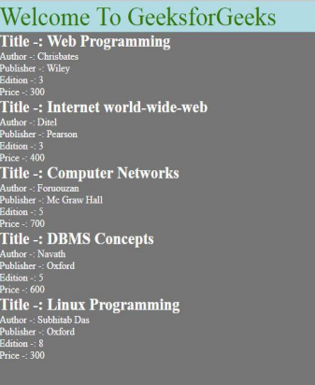

Assignemnt-IV
Title: Implement an application in Java Script using following:
a) Design UI of application using HTML, CSS etc.
b) Include Java script validation
c) Use of prompt and alert window using Java Script
Form Validation
In this document, we have discussed JavaScript Form Validation using a sample registration form. The tutorial explores JavaScript validation on submit with detail explanation. Following pictorial shows in which field, what validation we want to impose.
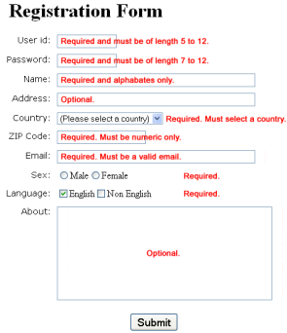
How would we set those validations
We will create JavaScript functions (one for each input field whose value is to validate) which check whether a value submitted by user passes the validation.
All those functions are called from another function.
It sets the focus to the input field until the user supplies a valid value.
When the user does so, they may proceed and can supply value to the next available field. The later JavaScript function created is called on the onsubmit event of the form.
HTML Code of the Sample Registration Form
<!DOCTYPE html>
<html lang="en"><head>
<meta charset="utf-8">
<title>JavaScript Form Validation using a sample registration form</title>
<meta name="keywords" content="example, JavaScript Form Validation, Sample registration form" />
<meta name="description" content="This document is an example of JavaScript Form Validation using a sample registration form. " />
<link rel='stylesheet' href='js-form-validation.css' type='text/css' />
<script src="sample-registration-form-validation.js"></script>
</head>
<body onload="document.registration.userid.focus();">
<h1>Registration Form</h1>
Use tab keys to move from one input field to the next.
<form name='registration' onSubmit="return formValidation();">
<ul>
<li><label for="userid">User id:</label></li>
<li><input type="text" name="userid" size="12" /></li>
<li><label for="passid">Password:</label></li>
<li><input type="password" name="passid" size="12" /></li>
<li><label for="username">Name:</label></li>
<li><input type="text" name="username" size="50" /></li>
<li><label for="address">Address:</label></li>
<li><input type="text" name="address" size="50" /></li>
<li><label for="country">Country:</label></li>
<li><select name="country">
<option selected="" value="Default">(Please select a country)</option> <option value="AF">Australia</option>
<option value="AL">Canada</option>
<option value="DZ">India</option>
<option value="AS">Russia</option>
<option value="AD">USA</option>
</select></li>
<li><label for="zip">ZIP Code:</label></li>
<li><input type="text" name="zip" /></li>
<li><label for="email">Email:</label></li>
<li><input type="text" name="email" size="50" /></li>
<li><label id="gender">Sex:</label></li>
<li><input type="radio" name="msex" value="Male" /><span>Male</span></li> <li><input type="radio" name="fsex" value="Female" /><span>Female</span></li> <li><label>Language:</label></li>
<li><input type="checkbox" name="en" value="en" checked /><span>English</span></li> <li><input type="checkbox" name="nonen" value="noen" /><span>Non English</span></li> <li><label for="desc">About:</label></li>
<li><textarea name="desc" id="desc"></textarea></li>
<li><input type="submit" name="submit" value="Submit" /></li>
</ul>
</form>
</body>
</html>
sample-registration-form-validation.js is the external JavaScript file which contains the JavaScript ocde used to validate the form. js-form-validation.css is the stylesheet containing styles for the form. Notice that for validation, the JavaScript function containing the code to validate is called on the onSubmit event of the form.
For the sake of demonstration, we have taken five countries only. You may add any number of countries in the list.
CSS Code of the Sample Registration Form
h1 {
margin-left: 70px;
}
form li {
list-style: none;
margin-bottom: 5px;
}
form ul li label{
float: left;
clear: left;
width: 100px;
text-align: right;
margin-right: 10px;
font-family:Verdana, Arial, Helvetica, sans-serif; font-size:14px;
}
form ul li input, select, span {
float: left;
margin-bottom: 10px;
}
form textarea {
float: left;
width: 350px;
height: 150px;
}
[type="submit"] {
clear: left;
margin: 20px 0 0 230px;
font-size:18px
}
p {
margin-left: 70px;
font-weight: bold;
}
JavaScript code for validation
JavaScript function which is called on onSubmit
This function calls all other functions used for validation. function formValidation()
{
var uid = document.registration.userid;
var passid = document.registration.passid;
var uname = document.registration.username;
var uadd = document.registration.address;
var ucountry = document.registration.country;
var uzip = document.registration.zip;
var uemail = document.registration.email;
var umsex = document.registration.msex;
var ufsex = document.registration.fsex; if(userid_validation(uid,5,12)) {
if(passid_validation(passid,7,12))
{
if(allLetter(uname))
{
if(alphanumeric(uadd))
{
if(countryselect(ucountry))
{
if(allnumeric(uzip))
{
if(ValidateEmail(uemail))
{
if(validsex(umsex,ufsex))
{
}
}
}
}
}
}
}
}
return false;
}
JavaScript function for validating userid
function userid_validation(uid,mx,my)
{
var uid_len = uid.value.length;
if (uid_len == 0 || uid_len >= my || uid_len < mx)
{
alert("User Id should not be empty / length be between "+mx+" to "+my); uid.focus();
return false;
}
return true;
}
The code above checks whether userid input field is provided with a string of length 5 to 12 characters. If not, it displays an alert.
Flowchart:
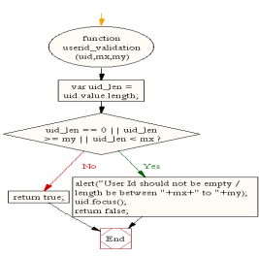
JavaScript function for validating password
function passid_validation(passid,mx,my)
{
var passid_len = passid.value.length;
if (passid_len == 0 ||passid_len >= my || passid_len < mx)
{
alert("Password should not be empty / length be between "+mx+" to "+my); passid.focus();
return false;
}
return true;
}
Copy
The above code used to validate password (it should be of length 7 to 12 characters). If not, it displays an alert.
Flowchart:
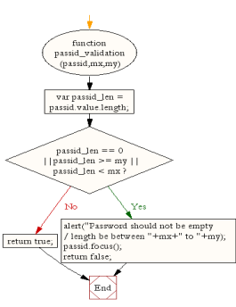
JavaScript code for validating user name
function allLetter(uname)
{
var letters = /^[A-Za-z]+$/;
if(uname.value.match(letters))
{
return true;
}
else
{
alert('Username must have alphabet characters only');
uname.focus();
return false;
}
}
Copy
The code above checks whether user name input field is provided with alphabates characters. If not, it displays an alert.
Flowchart:
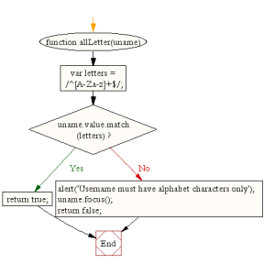
JavaScript code for validating user address
function alphanumeric(uadd)
{
var letters = /^[0-9a-zA-Z]+$/;
if(uadd.value.match(letters))
{
return true;
}
else
{
alert('User address must have alphanumeric characters only');
uadd.focus();
return false;
}
}
Copy
The code above checks whether user address input field is provided with alphanumeric characters. If not, it displays an alert.
Flowchart:
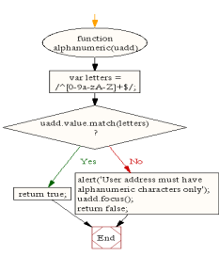
JavaScript code for validating country
function countryselect(ucountry)
{
if(ucountry.value == "Default")
{
alert('Select your country from the list');
ucountry.focus();
return false;
}
else
{
return true;
}
}
Copy
The code above checks whether a country is selected from the given list. If not, then it displays an alert.
Flowchart:
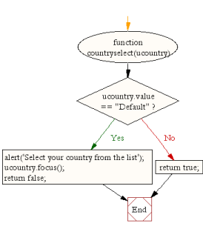
JavaScript code for validating ZIP code
function allnumeric(uzip)
{
var numbers = /^[0-9]+$/;
if(uzip.value.match(numbers))
{
return true;
}
else
{
alert('ZIP code must have numeric characters only');
uzip.focus();
return false;
}
}
Copy
The code above checks whether a ZIP code of numeric value. If not, it displays an alert. Flowchart:
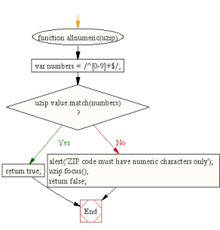
JavaScript code for validating email format
function ValidateEmail(uemail)
{
var mailformat = /^\w+([\.-]?\w+)*@\w+([\.-]?\w+)*(\.\w{2,3})+$/; if(uemail.value.match(mailformat))
{
return true;
}
else
{
alert("You have entered an invalid email address!");
uemail.focus();
return false;
}
}
Copy
The code above checks whether a valid email format is supplied. If not,it displays an alert. Flowchart:
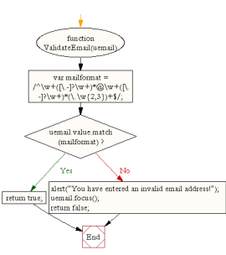
JavaScript code for validating gender
function validsex(umsex,ufsex)
{
x=0;
if(umsex.checked)
{
x++;
} if(ufsex.checked)
{
x++;
}
if(x==0)
{
alert('Select Male/Female');
umsex.focus();
return false;
}
else
{
alert('Form Successfully Submitted');
window.location.reload()
return true;}
}
Copy
The code above checks whether a sex is selected. If not, it displays an alert. If Male or Female is selected, it generates an alert saying that the form is successfully submitted and it reloads the form.
Flowchart:
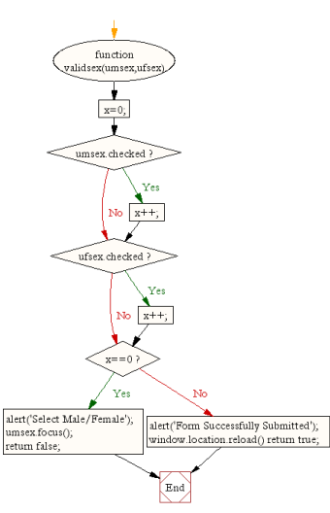
Here is the entire JavaScript used for validation of the form. function formValidation()
{
var uid = document.registration.userid;
var passid = document.registration.passid;
var uname = document.registration.username;
var uadd = document.registration.address;
var ucountry = document.registration.country;
var uzip = document.registration.zip;
var uemail = document.registration.email;
var umsex = document.registration.msex;
var ufsex = document.registration.fsex; if(userid_validation(uid,5,12)) {
if(passid_validation(passid,7,12))
{
if(allLetter(uname))
{
if(alphanumeric(uadd))
{
if(countryselect(ucountry))
{
if(allnumeric(uzip))
{
if(ValidateEmail(uemail))
{
if(validsex(umsex,ufsex))
{
}
}
}
}
}
}
}
}
return false;
} function userid_validation(uid,mx,my)
{
var uid_len = uid.value.length;
if (uid_len == 0 || uid_len >= my || uid_len < mx)
{
alert("User Id should not be empty / length be between "+mx+" to "+my); uid.focus();
return false;
}
return true;
}
function passid_validation(passid,mx,my)
{
var passid_len = passid.value.length;
if (passid_len == 0 ||passid_len >= my || passid_len < mx) {
alert("Password should not be empty / length be between "+mx+" to "+my); passid.focus();
return false;
}
return true;
}
function allLetter(uname)
{
var letters = /^[A-Za-z]+$/;
if(uname.value.match(letters))
{
return true;
}
else
{
alert('Username must have alphabet characters only');
uname.focus();
return false;
}
}
function alphanumeric(uadd)
{
var letters = /^[0-9a-zA-Z]+$/;
if(uadd.value.match(letters))
{
return true;
}
else
{
alert('User address must have alphanumeric characters only'); uadd.focus();
return false;
}
}
function countryselect(ucountry)
{
if(ucountry.value == "Default")
{
alert('Select your country from the list');
ucountry.focus();
return false;
}
else
{
return true;
}
}
function allnumeric(uzip)
{
var numbers = /^[0-9]+$/;
if(uzip.value.match(numbers))
{
return true;
}
else
{
alert('ZIP code must have numeric characters only'); uzip.focus();
return false;
}
}
function ValidateEmail(uemail)
{
var mailformat = /^\w+([\.-]?\w+)*@\w+([\.-]?\w+)*(\.\w{2,3})+$/; if(uemail.value.match(mailformat))
{
return true;
}
else
{
alert("You have entered an invalid email address!"); uemail.focus();
return false;
}
} function validsex(umsex,ufsex)
{
x=0;
if(umsex.checked)
{
x++;
} if(ufsex.checked)
{
x++;
}
if(x==0)
{
alert('Select Male/Female'); umsex.focus();
return false;
}
else
{
alert('Form Succesfully Submitted'); window.location.reload()
return true;
}
}
Flowchart:
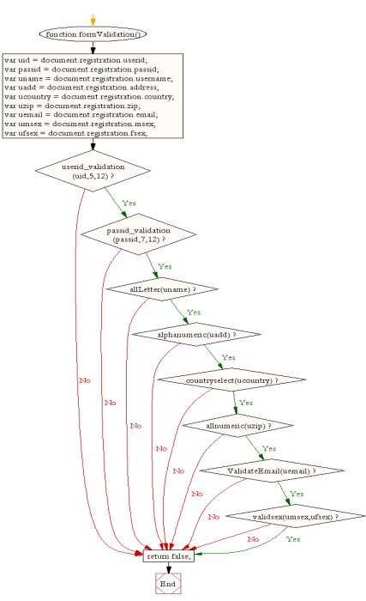
Assignment-V
Title: Java Server-side Programming: A Java Servlet e-Shop Case Study
Problem Statement: Implement the sample program demonstrating the use of Servlet. e.g., Create a database table ebookshop (book_id, book_title, book_author, book_price, quantity) using database like Oracle/MySQL etc. and display (use SQL select query) the table content using servlet.
1. Introduction
In this case study, we shall develop an e-shop based on the Java Servlet Technology. This e shop is a typical Internet business-to-consumer (B2C) 3-tier client/server database application, as illustrated below.
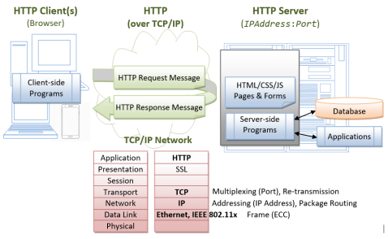A typical 3-tier client/server web database application consists of 5 components: 1. A HTTP Server (or commonly known as a Web Server), such as Apache HTTP Server,
Apache Tomcat Server, Microsoft Internet Information Server (IIS), Nginx, Google Web Server (GWS), and etc..
2. A HTTP Client, commonly known as a Web Browser, such as FireFox, Chrome, MSIE, Safari, and etc.
3. A Relational Database, such as MySQL, PostgreSQL, Oracle, IBM DB2, MS SQL Server, MS Access, SAP SyBase, and etc.
4. Client-side program, running inside the browser, which sends request to the server and receives server's response. Client-side program can be written in many technologies, e.g., HTML form, JavaScript, VBScript, and others.
5. Server-side program, running inside the HTTP server, which receives and processes clients' requests. The server-side program extracts the query parameters submitted by the client-side program and queries the database. Server-side program can also be written in many ways, e.g., Java Servlet/JSP/JSF, ASP, PHP, Python, JavaScript, and others.
The client and server interact with each other by exchanging messages using a protocol called HTTP (HyperText Transfer Protocol). HTTP is an asymmetric request-response protocol. A client sends a request message to the server. The server processes the request and returns a response message. In other words, in HTTP, the client pulls information from the server, instead of server pushes information to the client. An HTTP server typically runs over TCP/IP, with a server IP address and on a TCP port number. The default TCP port number for HTTP is 80.
A typical use case for a webapp is as follows:
1. A client issue an URL to request and download an HTML page containing an HTML form (or other client-side programs).
2. The client enters the requested data into the form (such as search criteria), and submits these query parameters back to a server-side program for processing.
3. The server-side program extracts the query parameters, performs the database query, and returns the query results back to the requesting client.
4. The client displays the query results, and repeats the above steps for further request response exchange.
In this article, we shall build our webapp in Java and MySQL. We shall write our server-side programs in Java servlets. We shall write our client-side programs in HTML forms.
2. Setting up the E-Shop's Database in MySQL
The first step in building our e-shop is to setup a database. We shall call our database "ebookshop" which contains one table "books". The table "books" has 5 columns: id, title, author, price and qty. The id column is the primary key of the table.
Database: ebookshop
Table: books
+-------+----------------------------+---------------+---------+-------+
| id | title | author | price | qty |
| (INT) | (VARCHAR(50)) | (VARCHAR(50)) | (FLOAT) | (INT) | +-------+----------------------------+---------------+---------+-------+
| 1001 | Java for dummies | Tan Ah Teck | 11.11 | 11 |
| 1002 | More Java for dummies | Tan Ah Teck | 22.22 | 22 |
| 1003 | More Java for more dummies | Mohammad Ali | 33.33 | 33 |
| 1004 | A Cup of Java | Kumar | 44.44 | 44 |
| 1005 | A Teaspoon of Java | Kevin Jones | 55.55 | 55 |
+-------+----------------------------+---------------+---------+-------+

MySQL
If you are new to MySQL, read "How to Set Up MySQL and Get Started".
Start the MySQL server. Take note of the server's TCP port number. I shall assume that MySQL server is running on port 3306. The default TCP port number for MySQL server is 3306.
// For Windows: assume that MySQL is installed in "c:\myWebProject\mysql" c:
cd \myWebProgram\mysql\bin
mysqld --console
// For macOS
// Use graphical control at "System Preferences" -> MySQL

Start a MySQL client. I shall also assume that there is an authorized user called "myuser" with password "xxxx".
// For Windows: assume that MySQL is installed in "c:\myWebProject\mysql" c:
cd \myWebProject\mysql\bin
mysql -u myuser -p
// For macOS: assume that MySQL is installed in "/usr/local/mysql"
cd /usr/local/mysql/bin
./mysql -u myuser –p

You can run the following SQL script to set up the database:
create database if not exists ebookshop;
use ebookshop;
drop table if exists books;
create table books (
id int,
title varchar(50),
author varchar(50),
price float,
qty int,
primary key (id));
insert into books values (1001, 'Java for dummies', 'Tan Ah Teck', 11.11, 11); insert into books values (1002, 'More Java for dummies', 'Tan Ah Teck', 22.22, 22); insert into books values (1003, 'More Java for more dummies', 'Mohammad Ali', 33.33, 33); insert into books values (1004, 'A Cup of Java', 'Kumar', 44.44, 44);
insert into books values (1005, 'A Teaspoon of Java', 'Kevin Jones', 55.55, 55); select * from books;

3. Setting up HTTP Server with Apache Tomcat
Next, we have to setup an HTTP server to host our webapp. In this case study, we shall use Apache Tomcat Server as our HTTP server. Read "How to install Apache Tomcat server". I shall assume that our Tomcat is running in TCP port number 9999.
4. Setting up the E-Shop Webapp under Apache Tomcat
Step 1: Create the Directory Structure for a new Webapp "ebookshop"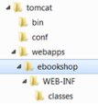
First of all, choose a name for your webapp. In this case study, we shall call it "ebookshop". Navigate to Tomcat's "webapps" sub-directory, and create the following directory structure: 1. Under Tomcat's "webapps" directory, create you web application root directory "ebookshop".
2. Under "ebookshop", create a sub-directory "WEB-INF" (case sensitive, uppercase, a dash not underscore).
3. Under "WEB-INF", create a sub-directory "classes" (case sensitive, lowercase, plural). You need to keep your web resources in the proper directories:
1. "ebookshop": The is called the context root (or document base directory) of your webapp. You should keep all your HTML files and resources visible to the web users (e.g., CSS, images, scripts) here.
2. "ebookshop\WEB-INF": This directory, although under the context root, is not visible to the web users. This is where you keep your application's configuration files "web.xml". 3. "ebookshop\WEB-INF\classes": This is where you keep all the Java source files and classes.
Step 2: Start the Tomcat Server
To start the Tomcat server:
∙ For Windows: start a CMD shell and run the batch file "startup.bat" under Tomcat's "bin" directory. Tomcat will be started in a new console window.
∙ For macOS and Linux: start a Terminal and run "./catalina.sh run"under Tomcat's "bin" directory.
Monitor the Tomcat console, as the error messages, and output of System.out.println() from your programs will be sent to this console. Observe the Tomcat's TCP port number.
.....
xxxxxx INFO [main] org.apache.catalina.startup.HostConfig.deployDirectory
Deploying web application directory [xxx\webapps\ebookshop]
xxxxxx INFO [main] org.apache.catalina.startup.HostConfig.deployDirectory Deployment of web application directory [xxx\webapps\ebookshop] has finished in [188] ms ......
xxxxxx INFO [main] org.apache.coyote.AbstractProtocol.start Starting ProtocolHandler ["http-nio-9999"]
xxxxxx INFO [main] org.apache.coyote.AbstractProtocol.start Starting ProtocolHandler ["ajp nio-8009"]
xxxxxx INFO [main] org.apache.catalina.startup.Catalina.start Server startup in 1927 ms

Step 3: Access the Tomcat Server
The Tomcat Server has been started on TCP port 9999. The default TCP port number for HTTP protocol is 80. To access an HTTP server not running on the default TCP port 80, the port number must be explicitly specified in the URL.
To access your Tomcat Server, start a web browser (e.g., FireFox, IE, Chrome or Safari) and issue the following URL:
http://localhost:9999

The "localhost" is a special hostname (with IP address of 127.0.0.1) meant for local loop back testing.
You could also use the IP address to access your HTTP server. You can find out your IP address by running program such as "ipconfig", "winipcfg" (Windows), "ifconfig" (macOS/Linux), and etc.
You shall see the welcome page of Tomcat Server.
Step 5: Shutting down the Tomcat Server.
To orderly shutdown the Tomcat web server, press control-c from the Tomcat's console; or run the script "shutdown.bat" (Windows) or "./shutdown.sh" (macOS/Linux) under Tomcat's "bin" directory.
5. Writing a Client-Side HTML Form
Let's write an HTML script to create a query form using checkboxes. Save the HTML file as "querybook.html" in your application root directory "ebookshop".
<html>
<head>
<title>Yet Another e-Bookshop</title>
</head>
<body>
<h2>Yet Another e-Bookshop</h2>
<form method="get" action="http://localhost:9999/ebookshop/query"> Choose an author:<br /><br />
<input type="checkbox" name="author" value="Tan Ah Teck" />Ah Teck <input type="checkbox" name="author" value="Mohammad Ali" />Ali <input type="checkbox" name="author" value="Kumar" />Kumar
<input type="submit" value="Search" />
</form>
</body>
</html>

Browse the HTML page by issuing the URL:
http://localhost:9999/ebookshop/querybook.html

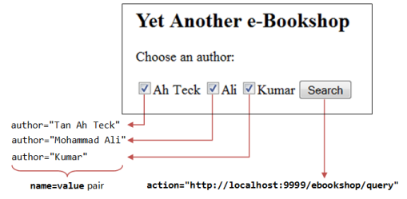Check a box (e.g., Ah Teck) and click the "Search" button. A request will be issued to the URL specified in the <form>'s action attribute. You are expected to receive an Error "404 Page Not Found" at this stage as you have yet to write the server-side program (i.e., "query").
But observe the URL generated:
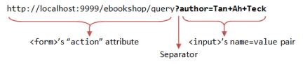The query parameter, in the form of name=value pair, are extracted from the <input> tag (e.g., author=Tan+Ah+Tack). It is appended behind the URL, separated by a '?'.
Check two boxes (e.g., "Ah Teck" and "Ali") and submit the request, the URL is:
http://localhost:9999/ebookshop/query?author=Tan+Ah+Teck&author=Mohammad+Ali

Two name=value pairs are sent to the server, separated by an '&'.
Also take note that blank is replaced by '+'. This is because special characters are not permitted in the URL. They are encoded as %xx where xx is the hex code in ASCII. For example, '~' is encoded as %7e; blank is encoded as %20 or '+'.
6. Writing Database Query Servlet
The next step is to write the server-side program, which responses to the client's request by querying the database and returns the query results. We shall use Java servlet technology in our servlet-side programming.
6.1 Java Database Programming
The steps involved in Java database programs are:
1. Allocate a Connection object.
2. Allocate a Statement object, under the Connection object created.
3. Query database:
a. Execute a SQL SELECT query by calling the executeQuery() method of the Statement object, which returns the query results in a ResultSet object; or b. Execute a SQL INSERT|UPDATE|DELETE command by calling the executeUpdate() method of the Statement object, which returns an int indicating the number of rows affected.
4. Process the query result.
5. Free the resources by closing the Statement and Connection.
6.2 Database Servlet
Let write a servlet that queries the database based on the client's request.
Step 1: Write the Servlet "QueryServlet.java"
Enter the following codes and save as "QueryServlet.java" under your web application "classes" directory, i.e., "ebookshop\WEB-INF\classes\". You must keep all your servlets in "ebookshop\WEB-INF\classes", because that is where Tomcat picks up the servlets.
1
// To save as "ebookshop\WEB-INF\classes\QueryServlet.java".
2
import java.io.*;
3
import java.sql.*;
4
import jakarta.servlet.*; // Tomcat 10
5
import jakarta.servlet.http.*;
6
import jakarta.servlet.annotation.*;
7
//import javax.servlet.*; // Tomcat 9
8
//import javax.servlet.http.*;
9
//import javax.servlet.annotation.*;
10
11
@WebServlet("/query") // Configure the request URL for this servlet (Tomcat 7/Servlet 3.0 upwards) 12
public class QueryServlet extends HttpServlet {
13
14
// The doGet() runs once per HTTP GET request to this servlet.
15
@Override
16
public void doGet(HttpServletRequest request, HttpServletResponse response) 17
throws ServletException, IOException {
18
// Set the MIME type for the response message
19
response.setContentType("text/html");
20
// Get a output writer to write the response message into the network socket
21
PrintWriter out = response.getWriter();
22
// Print an HTML page as the output of the query
23
out.println("<html>");
24
out.println("<head><title>Query Response</title></head>");
25
out.println("<body>");
26
27
try (
28
// Step 1: Allocate a database 'Connection' object
29
Connection conn = DriverManager.getConnection(
30
"jdbc:mysql://localhost:3306/ebookshop?allowPublicKeyRetrieval=true&useSSL=false&31
"myuser", "xxxx"); // For MySQL
32
// The format is: "jdbc:mysql://hostname:port/databaseName", "username", "password" 33
34
// Step 2: Allocate a 'Statement' object in the Connection
35
Statement stmt = conn.createStatement();
36
) {
37
// Step 3: Execute a SQL SELECT query
38
String sqlStr = "select * from books where author = "
39
+ "'" + request.getParameter("author") + "'" // Single-quote SQL string 40
+ " and qty > 0 order by price desc";
41
42
out.println("<h3>Thank you for your query.</h3>");
43
out.println("<p>Your SQL statement is: " + sqlStr + "</p>"); // Echo for debugging 44
ResultSet rset = stmt.executeQuery(sqlStr); // Send the query to the server 45
46
// Step 4: Process the query result set
47
int count = 0;
48
while(rset.next()) {
49
// Print a paragraph <p>...</p> for each record
50
out.println("<p>" + rset.getString("author")
51
+ ", " + rset.getString("title")
52
+ ", $" + rset.getDouble("price") + "</p>");
53
count++;
54
}
55
out.println("<p>==== " + count + " records found =====</p>");
56
} catch(Exception ex) {
57
out.println("<p>Error: " + ex.getMessage() + "</p>");
58
out.println("<p>Check Tomcat console for details.</p>");
59
ex.printStackTrace();
60
} // Step 5: Close conn and stmt - Done automatically by try-with-resources (JDK 7) 61
62
out.println("</body></html>");
63
out.close();
64
}
65
}
Recall that the HTML form that we created earlier submits query parameters in the form of name=value pairs, (e.g., author=Tan+Ah+Teck), as part of the request. In the processing servlet, we need to extract the author name (e.g., "Tan Ah Teck") from the request to form a SQL SELECT query (e.g., SELECT * FROM books WHERE author='Tan Ah Teck'). This is done via the method request.getParameter(name), which returns the value of the name=value pair.
For example, suppose that the URL is:
http://localhost:9999/ebookshop/query?author=Tan+Ah+Teck

The method request.getParameter("author") returns a String "Tan Ah Teck". The resultant sqlStr becomes:
SELECT * FROM books WHERE author='Tan Ah Teck' AND qty > 0 ORDER BY author ASC, title ASC

Note that you do not have to handle encoded characters such as '+', %20, '?' and '&'. They will be properly decoded by the getParameter() method.
Step 2: Compile
Compile the source code "QueryServlet.java" into "QueryServlet.class".
// For Windows: Assume that Tomcat is installed in "c:\myWebProject\tomcat" c:
cd \myWebProject\tomcat\webapps\ebookshop\WEB-INF\classes
javac -cp .;c:\myWebProject\tomcat\lib\servlet-api.jar QueryServlet.java
// For macOS: Assume that Tomcat is installed in "~/myWebProject/tomcat" cd ~/myWebProject/tomcat/webapps/ebookshop/WEB-INF/classes
// Need to use $HOME instead of ~ in the "javac" command
javac -cp .:$HOME/myWebProject/tomcat/lib/servlet-api.jar QueryServlet.java

Step 3: Test the Servlet
You can now try to invoke the servlet by issuing a request URL with proper query parameter:
http://localhost:9999/ebookshop/query?author=Tan+Ah+Teck

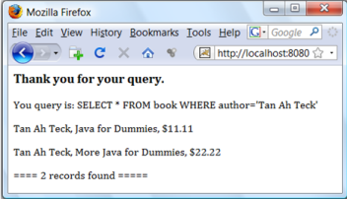
The request URL "/query" is mapped to the servlet "QueryServlet.class", as configured via @WebServlet("/query"), as follows:
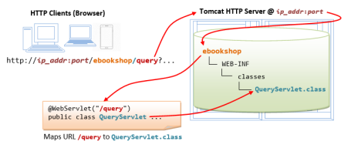
Try "View Source" (or "View Page Source") in your browser to study the output produced by the servlet. It is important to note that the client has no access to the servlet's program codes, but merely the outputs produced by the servlet.
<html>
<head><title>Query Results</title></head>
<body>
<h3>Thank you for your query.</h3>
<p>Your SQL statement: SELECT * FROM books WHERE author = 'Tan Ah Teck' AND qty > 0 ORDER BY author ASC, title ASC</p>
<p>Tan Ah Teck, Java for dummies, $11.11</p>
<p>Tan Ah Teck, More Java for dummies, $22.22</p>
<p>==== 2 records found ====</p>
</body></html>

Step 5: Invoke the Servlet from the HTML Form
Use the HTML form that you have created earlier (i.e., "querybook.html") to trigger this servlet. Take note that the request URL is coded in the <form>'s action attribute.

Assignment VI
Implement the program demonstrating the use of JSP.
JDBC Tutorial
JDBC API is a Java API that can access any kind of tabular data, especially data stored in a Relational Database. JDBC works with Java on a variety of platforms, such as Windows, Mac OS, and the various versions of UNIX.
Why to Learn JDBC?
JDBC stands for Java Database Connectivity, which is a standard Java API for database independent connectivity between the Java programming language and a wide range of databases.
The JDBC library includes APIs for each of the tasks mentioned below that are commonly associated with database usage.
∙ Making a connection to a database.
∙ Creating SQL or MySQL statements.
∙ Executing SQL or MySQL queries in the database.
∙ Viewing & Modifying the resulting records.
Applications of JDBC
Fundamentally, JDBC is a specification that provides a complete set of interfaces that allows for portable access to an underlying database. Java can be used to write different types of executables, such as −
∙ Java Applications
∙ Java Applets
∙ Java Servlets
∙ Java ServerPages (JSPs)
∙ Enterprise JavaBeans (EJBs).
All of these different executables are able to use a JDBC driver to access a database, and take advantage of the stored data.
JDBC provides the same capabilities as ODBC, allowing Java programs to contain database independent code.
The JDBC 4.0 Packages
The java.sql and javax.sql are the primary packages for JDBC 4.0. This is the latest JDBC version at the time of writing this tutorial. It offers the main classes for interacting with your data sources.
The new features in these packages include changes in the following areas −
∙ Automatic database driver loading.
∙ Exception handling improvements.
∙ Enhanced BLOB/CLOB functionality.
∙ Connection and statement interface enhancements.
∙ National character set support.
∙ SQL ROWID access.
∙ SQL 2003 XML data type support.
∙ Annotations.
To start with basic concept, let us create a table and create a few records in that table as follows −
Create Table
To create the Employees table in the EMP database, use the following steps − Step 1
Open a Command Prompt and change to the installation directory as follows −
C:\>
C:\>cd Program Files\MySQL\bin
C:\Program Files\MySQL\bin>

Step 2
Login to the database as follows −
C:\Program Files\MySQL\bin>mysql -u root -p
Enter password: ********
mysql>

Step 3
Create the Employee table in the TEST database as follows − −
mysql> use TEST;
mysql> create table Employees
(
id int not null,
age int not null,
first varchar (255),
last varchar (255)
);
Query OK, 0 rows affected (0.08 sec)
mysql>

Create Data Records
Let us now create a few records in the Employee table as follows − −
mysql> INSERT INTO Employees VALUES (100, 18, 'Zara', 'Ali');
Query OK, 1 row affected (0.05 sec)

mysql> INSERT INTO Employees VALUES (101, 25, 'Mahnaz', 'Fatma'); Query OK, 1 row affected (0.00 sec)
mysql> INSERT INTO Employees VALUES (102, 30, 'Zaid', 'Khan');
Query OK, 1 row affected (0.00 sec)
mysql> INSERT INTO Employees VALUES (103, 28, 'Sumit', 'Mittal');
Query OK, 1 row affected (0.00 sec)
mysql>

SELECT Operation
Following example shows how we can execute the SQL SELECT statement using JTSL in JSP programming −
<%@ page import = "java.io.*,java.util.*,java.sql.*"%>
<%@ page import = "javax.servlet.http.*,javax.servlet.*" %>
<%@ taglib uri="http://java.sun.com/jsp/jstl/core" prefix = "c"%>
<%@ taglib uri="http://java.sun.com/jsp/jstl/sql" prefix = "sql"%>
<html>
<head>
<title>SELECT Operation</title>
</head>
<body>
<sql:setDataSource var = "snapshot" driver = "com.mysql.jdbc.Driver" url = "jdbc:mysql://localhost/TEST"
user = "root" password = "pass123"/>
<sql:query dataSource = "${snapshot}" var = "result">
SELECT * from Employees;
</sql:query>
<table border = "1" width = "100%">
<tr>
<th>Emp ID</th>
<th>First Name</th>
<th>Last Name</th>
<th>Age</th>
</tr>

<c:forEach var = "row" items = "${result.rows}">
<tr>
<td><c:out value = "${row.id}"/></td>
<td><c:out value = "${row.first}"/></td>

<td><c:out value = "${row.last}"/></td>
<td><c:out value = "${row.age}"/></td>
</tr>
</c:forEach>
</table>
</body>
</html>

Access the above JSP, the following result will be displayed −
Emp ID | First Name | Last Name | Age
100 | Zara | Ali | 18
101 | Mahnaz | Fatma | 25
102 | Zaid | Khan | 30
103 | Sumit | Mittal | 28

INSERT Operation
Following example shows how we can execute the SQL INSERT statement using JTSL in JSP programming −
<%@ page import = "java.io.*,java.util.*,java.sql.*"%>
<%@ page import = "javax.servlet.http.*,javax.servlet.*" %>
<%@ taglib uri="http://java.sun.com/jsp/jstl/core" prefix = "c"%>
<%@ taglib uri="http://java.sun.com/jsp/jstl/sql" prefix = "sql"%>
<html>
<head>
<title>JINSERT Operation</title>
</head>

<body>
<sql:setDataSource var = "snapshot" driver = "com.mysql.jdbc.Driver" url = "jdbc:mysql://localhost/TEST"
user = "root" password = "pass123"/>
<sql:update dataSource = "${snapshot}" var = "result">
INSERT INTO Employees VALUES (104, 2, 'Nuha', 'Ali');
</sql:update>
<sql:query dataSource = "${snapshot}" var = "result">
SELECT * from Employees;
</sql:query>

<table border = "1" width = "100%">
<tr>
<th>Emp ID</th>
<th>First Name</th>
<th>Last Name</th>
<th>Age</th>
</tr>

<c:forEach var = "row" items = "${result.rows}">
<tr>
<td><c:out value = "${row.id}"/></td>
<td><c:out value = "${row.first}"/></td>
<td><c:out value = "${row.last}"/></td>
<td><c:out value = "${row.age}"/></td>
</tr>
</c:forEach>
</table>
</body>
</html>

Access the above JSP, the following result will be displayed −
Emp ID | First Name | Last Name | Age
100 | Zara | Ali | 18
101 | Mahnaz | Fatma | 25
102 | Zaid | Khan | 30
103 | Sumit | Mittal | 28
104 | Nuha | Ali | 2

DELETE Operation
Following example shows how we can execute the SQL DELETE statement using JTSL in JSP programming −
<%@ page import = "java.io.*,java.util.*,java.sql.*"%>
<%@ page import = "javax.servlet.http.*,javax.servlet.*" %>
<%@ taglib uri="http://java.sun.com/jsp/jstl/core" prefix = "c"%>
<%@ taglib uri="http://java.sun.com/jsp/jstl/sql" prefix = "sql"%>
<html>

<head>
<title>DELETE Operation</title>
</head>

<body>
<sql:setDataSource var = "snapshot" driver = "com.mysql.jdbc.Driver" url = "jdbc:mysql://localhost/TEST"
user = "root" password = "pass123"/>
<c:set var = "empId" value = "103"/>
<sql:update dataSource = "${snapshot}" var = "count">
DELETE FROM Employees WHERE Id = ?
<sql:param value = "${empId}" />
</sql:update>
<sql:query dataSource = "${snapshot}" var = "result">
SELECT * from Employees;
</sql:query>
<table border = "1" width = "100%">
<tr>
<th>Emp ID</th>
<th>First Name</th>
<th>Last Name</th>
<th>Age</th>
</tr>

<c:forEach var = "row" items = "${result.rows}">
<tr>
<td><c:out value = "${row.id}"/></td>
<td><c:out value = "${row.first}"/></td>
<td><c:out value = "${row.last}"/></td>
<td><c:out value = "${row.age}"/></td>
</tr>
</c:forEach>
</table>
</body>
</html>

Access the above JSP, the following result will be displayed −
Emp ID | First Name | Last Name | Age
100 | Zara | Ali | 18
101 | Mahnaz | Fatma | 25
102 | Zaid | Khan | 30

UPDATE Operation
Following example shows how we can execute the SQL UPDATE statement using JTSL in JSP programming −
<%@ page import = "java.io.*,java.util.*,java.sql.*"%>
<%@ page import = "javax.servlet.http.*,javax.servlet.*" %>
<%@ taglib uri = "http://java.sun.com/jsp/jstl/core" prefix = "c"%>
<%@ taglib uri = "http://java.sun.com/jsp/jstl/sql" prefix = "sql"%>
<html>
<head>
<title>DELETE Operation</title>
</head>

<body>
<sql:setDataSource var = "snapshot" driver = "com.mysql.jdbc.Driver" url = "jdbc:mysql://localhost/TEST"
user = "root" password = "pass123"/>
<c:set var = "empId" value = "102"/>
<sql:update dataSource = "${snapshot}" var = "count">
UPDATE Employees SET WHERE last = 'Ali'
<sql:param value = "${empId}" />
</sql:update>
<sql:query dataSource = "${snapshot}" var = "result">
SELECT * from Employees;
</sql:query>
<table border = "1" width = "100%">
<tr>
<th>Emp ID</th>
<th>First Name</th>
<th>Last Name</th>
<th>Age</th>
</tr>

<c:forEach var = "row" items = "${result.rows}">
<tr>
<td><c:out value = "${row.id}"/></td>
<td><c:out value = "${row.first}"/></td>
<td><c:out value = "${row.last}"/></td>
<td><c:out value = "${row.age}"/></td>
</tr>
</c:forEach>
</table>
</body>
</html>

Access the above JSP, the following result will be displayed −
Emp ID | First Name | Last Name | Age
100 | Zara | Ali | 18
101 | Mahnaz | Fatma | 25
102 | Zaid | Ali | 30

Assignment –VII
PHP + MySQL Database System
∙ PHP combined with MySQL are cross-platform (you can develop in Windows and serve on a Unix platform)
Database Queries
A query is a question or a request.
We can query a database for specific information and have a recordset returned. Look at the following query (using standard SQL):
SELECT LastName FROM Employees
The query above selects all the data in the "LastName" column from the "Employees" table. To learn more about SQL, please visit our SQL tutorial.
Download MySQL Database
If you don't have a PHP server with a MySQL Database, you can download it for free here: http://www.mysql.com
Facts About MySQL Database
MySQL is the de-facto standard database system for web sites with HUGE volumes of both data and end-users (like Facebook, Twitter, and Wikipedia).
Another great thing about MySQL is that it can be scaled down to support embedded database applications.
Look at http://www.mysql.com/customers/ for an overview of companies using MySQL. Open a Connection to MySQL
Before we can access data in the MySQL database, we need to be able to connect to the server:
Example (MySQLi Object-Oriented)Get your own PHP Server
<?php
$servername = "localhost";
$username = "username";
$password = "password";
// Create connection
$conn = new mysqli($servername, $username, $password);
// Check connection
if ($conn->connect_error) {
die("Connection failed: " . $conn->connect_error);
}
echo "Connected successfully";
?>
Close the Connection
The connection will be closed automatically when the script ends. To close the connection before, use the following:
MySQLi Object-Oriented:
$conn->close();
Create a MySQL Database Using MySQLi
The CREATE DATABASE statement is used to create a database in MySQL. The following examples create a database named "myDB":
Example (MySQLi Object-oriented)
<?php
$servername = "localhost";
$username = "username";
$password = "password";
// Create connection
$conn = new mysqli($servername, $username, $password);
// Check connection
if ($conn->connect_error) {
die("Connection failed: " . $conn->connect_error);
}
// Create database
$sql = "CREATE DATABASE myDB";
if ($conn->query($sql) === TRUE) {
echo "Database created successfully";
} else {
echo "Error creating database: " . $conn->error;
}
$conn->close();
?>
Create a MySQL Table Using MySQLi
The CREATE TABLE statement is used to create a table in MySQL.
We will create a table named "MyGuests", with five columns: "id", "firstname", "lastname", "email" and "reg_date":
CREATE TABLE MyGuests (
id INT(6) UNSIGNED AUTO_INCREMENT PRIMARY KEY,
firstname VARCHAR(30) NOT NULL,
lastname VARCHAR(30) NOT NULL,
email VARCHAR(50),
reg_date TIMESTAMP DEFAULT CURRENT_TIMESTAMP ON UPDATE CURRENT_TIMESTAMP
)
Example (MySQLi Object-oriented)
<?php
$servername = "localhost";
$username = "username";
$password = "password";
$dbname = "myDB";
// Create connection
$conn = new mysqli($servername, $username, $password, $dbname); // Check connection
if ($conn->connect_error) {
die("Connection failed: " . $conn->connect_error);
}
// sql to create table
$sql = "CREATE TABLE MyGuests (
id INT(6) UNSIGNED AUTO_INCREMENT PRIMARY KEY,
firstname VARCHAR(30) NOT NULL,
lastname VARCHAR(30) NOT NULL,
email VARCHAR(50),
reg_date TIMESTAMP DEFAULT CURRENT_TIMESTAMP ON UPDATE CURRENT_TIMESTAMP
)";
if ($conn->query($sql) === TRUE) {
echo "Table MyGuests created successfully";
} else {
echo "Error creating table: " . $conn->error;
}
$conn->close();
?>
Insert Data Into MySQL Using MySQLi
After a database and a table have been created, we can start adding data in them. Here are some syntax rules to follow:
∙ The SQL query must be quoted in PHP
∙ String values inside the SQL query must be quoted
∙ Numeric values must not be quoted
∙ The word NULL must not be quoted
The INSERT INTO statement is used to add new records to a MySQL table:
INSERT INTO table_name (column1, column2, column3,...) VALUES (value1, value2, value3,...)
Example (MySQLi Object-oriented)
<?php
$servername = "localhost";
$username = "username";
$password = "password";
$dbname = "myDB";
// Create connection
$conn = new mysqli($servername, $username, $password, $dbname); // Check connection
if ($conn->connect_error) {
die("Connection failed: " . $conn->connect_error);
}
$sql = "INSERT INTO MyGuests (firstname, lastname, email) VALUES ('John', 'Doe', 'john@example.com')";
if ($conn->query($sql) === TRUE) {
echo "New record created successfully";
} else {
echo "Error: " . $sql . "<br>" . $conn->error;
}
$conn->close();
?>
Select Data From a MySQL Database
The SELECT statement is used to select data from one or more tables: SELECT column_name(s) FROM table_name
or we can use the * character to select ALL columns from a table:
SELECT * FROM table_name
To learn more about SQL, please visit our SQL tutorial.
Select Data With MySQLi
The following example selects the id, firstname and lastname columns from the MyGuests table and displays it on the page:
Example (MySQLi Object-oriented)Get your own PHP Server
<?php
$servername = "localhost";
$username = "username";
$password = "password";
$dbname = "myDB";
// Create connection
$conn = new mysqli($servername, $username, $password, $dbname); // Check connection
if ($conn->connect_error) {
die("Connection failed: " . $conn->connect_error);
}
$sql = "SELECT id, firstname, lastname FROM MyGuests";
$result = $conn->query($sql);
if ($result->num_rows > 0) {
// output data of each row
while($row = $result->fetch_assoc()) {
echo "id: " . $row["id"]. " - Name: " . $row["firstname"]. " " . $row["lastname"]. "<br>"; }
} else {
echo "0 results";
}
$conn->close();
?>

Assignment-VIII
Struts2 Login Page with Validation
Apache Struts 2 is an open-source web application framework for developing Java EE web applications. It uses and extends the Java Servlet API to encourage developers to adopt a model– view–controller architecture. In this article, we will see how we can create a login page with validations using Struts 2. We will use struts UI tags to create a login page.
Before creating your Struts2 project it is important to make sure that you have the Apache Tomcat server installed and configured with the IDE of your choice like Eclipse. Now, if the above conditions are fulfilled then follow all the steps given below. We are going to use Eclipse IDE so that all the required components will be created under a Dynamic Web Project. Let us now start with creating Dynamic Web Project.
Creating Dynamic Web Project
First, you simply need to start your Eclipse IDE and create a new Dynamic Web Project project. To do this go to File > New > Dynamic Web Project and enter the project name as per your wish. I have named it “struts_validation”
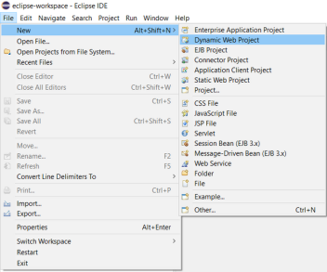
Set the rest of the options as given in the following screen
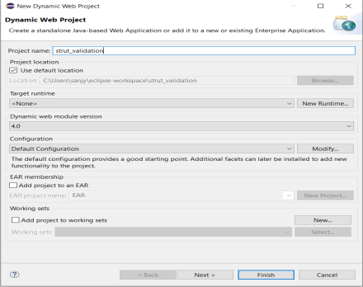
Select all the default options on the next screens and don’t forget to check the Generate web.xml deployment descriptor option
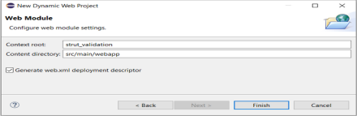This will create a dynamic web project for you in Eclipse.
Setup Struts2 Libraries
Now to run the Struts2 application, you need to set up your Struts2 framework.
1. You need to download and install Struts2 on your machine.
2. Download the latest version of Struts2 binaries from here.
3. At the time of writing this article, I downloaded struts-2.5.30-min-lib.zip. 4. After unzipping the downloaded file, you will get files inside struts-2.5.30/lib as follows:
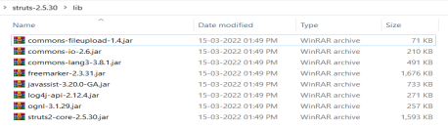
Now copy all the files from the struts-2.2.3\lib folder to your project’s WEB-INF\lib folder. You can do this by simply dragging and dropping all the files into the WEB-INF\lib folder. Your project structure should now look like this
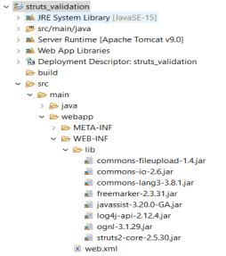
1. web.xml File:
Create a web.xml file under the webapp/WEB-INF folder and copy the following code in web.xml.
<?xml version="1.0" encoding="UTF-8"?>
<web-app xmlns:xsi="http://www.w3.org/2001/XMLSchema-instance" xmlns="http://xmlns.jcp.org/xml/ns/javaee"
xsi:schemaLocation="http://xmlns.jcp.org/xml/ns/javaee
http://xmlns.jcp.org/xml/ns/javaee/web-app_4_0.xsd" id="WebApp_ID" version="4.0">

<display-name>struts_validation</display-name>

<welcome-file-list>
<welcome-file>index.jsp</welcome-file>
</welcome-file-list>

<filter>
<filter-name>struts2</filter-name>
<filter
class>org.apache.struts2.dispatcher.filter.StrutsPrepareAndExecuteFilter</filter-class> </filter>

<filter-mapping>
<filter-name>struts2</filter-name>
<url-pattern>/*</url-pattern>
</filter-mapping>
</web-app>

2. index.jsp File:
We need a JSP file to display the final result, this page will be called by the Struts 2 framework where a predefined action will be called and this mapping is defined in the struts.xml file. So we will now create an index.jsp under the webapp folder in your eclipse project. To create a JSP file, right-click on the webapp folder in the project explorer and select New >JSP File.
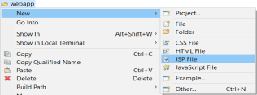
Now copy the following code into the index.jsp file
<%@ page language="java" contentType="text/html; charset=UTF-8"
pageEncoding="UTF-8"%>
<%@taglib uri="/struts-tags" prefix="s" %>
<!DOCTYPE html>
<html>
<head>
<meta charset="UTF-8">
<title>Login</title>
<s:head />
</head>
<body bgColor="lightGreen">
<s:form action="Login">
<s:textfield name="userName" label="User Name" placeholder="Default 'Sanjyot'"/> <s:password name="password" label="Password" />
<s:textfield name="phoneNumber" label="Phone Number" placeholder="10 digit phone number"/>
<s:textfield name="email" label="Email" type="email" />
<s:submit value="Login" />
</s:form>
</body>
</html>

The <%@taglib uri=”/struts-tags” prefix=”s” %> is a directive that tells the Servlet Container that this page will be using the Struts2 tags and these tags will be preceded by s. The s:form tag contains all the form elements. When the user clicks on the Login button, the request is forwarded to the Login action class.
3. welcome.jsp File:
Create welcome.jsp under the webapp folder and copy the following code into welcome.jsp
<%@ page language="java" contentType="text/html; charset=UTF-8"
pageEncoding="UTF-8"%>
<%@taglib uri="/struts-tags" prefix="s" %>
<!DOCTYPE html>
<html>
<head>
<meta charset="UTF-8">
<title>Login Successful</title>
</head>
<body>

<h3> Congratulations! You have logged in successfully.</h3>
<h4> Welcome <s:property value="userName"/>!!! </h4>
</body>

4. Action class: Login.java File
Our Login class extends ActionSupport. It is good to extend ActionSupport class as it provides a default implementation for most common tasks. Create a Login.java class and Copy the following code into Login.java
package com.SanjyotPanure.struts2;
import com.opensymphony.xwork2.ActionSupport;
public class Login extends ActionSupport {
private String userName;
private String password;
private String phoneNumber;
private String email;
public String execute() {
return SUCCESS;
}
public String getUserName() {
return userName;
}
public void setUserName(String userName) {
this.userName = userName;
}
public String getPassword() {
return password;
}
public void setPassword(String password) {
this.password = password;
}
public String getPhoneNumber() {
return phoneNumber;

}
public void setPhoneNumber(String phoneNumber) {
this.phoneNumber = phoneNumber;
}
public String getEmail() {
return email;
}
public void setEmail(String email) {
this.email = email;
}
public void validate() {
if (getUserName().length() == 0) {
addFieldError("userName", "UserName is required");
}
else if (!getUserName().equals("Sanjyot")) {
addFieldError("userName", "Invalid User");
}

if (getPassword().length() == 0) {
addFieldError("password", getText("Password is required"));
}

if (getPhoneNumber().length() == 0) {
addFieldError("phoneNumber", getText("Phone Number is required")); }
else if (!(getPhoneNumber().length() == 10)) {
addFieldError("phoneNumber", "Enter 10 digit phone number"); }
if (getEmail().length() == 0) {
addFieldError("email", getText("Email is required"));
}

}
}

5. struts.xml File:
We need a mapping between URL to action mapping. The struts.xml maps the Login class, and the welcome.jsp together. The mapping tells the Struts 2 framework which class will respond to the user’s action (the URL), which method of that class will be executed, and what view to
render based on the String result that method returns. So we will now create a struts.xml file under the webapp/WEB-INF folder. Copy the following code into struts.xml:
<?xml version="1.0" encoding="UTF-8"?>
<!DOCTYPE struts PUBLIC
"-//Apache Software Foundation//DTD Struts Configuration 2.0//EN" "http://struts.apache.org/dtds/struts-2.0.dtd">
<struts>
<constant name="struts.custom.i18n.resources" value="LoginAction" /> <package name="default" extends="struts-default" namespace="/"> <action name="Login" class="com.SanjyotPanure.struts2.Login" > <result name="success">welcome.jsp</result>
<result name="input">index.jsp</result>
</action>
</package>
</struts>

Here our “default” package extends the “struts-default” package. By extending the “struts default” package the action will by default inherit the set of interceptors defined in the default stack. The “struts-default” package is defined in the struts-default.xml file.
How to run the project?
Right-click on project > run as > run on server
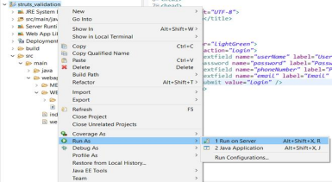If you’re running your project for the first time you’ll get a prompt as follows:
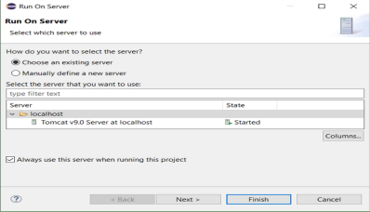Output
Now expand localhost and select your tomcat server. After this click on the next and finish. You will see a web page opened on your Eclipse IDE like this:
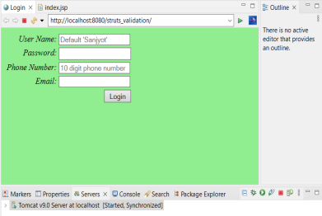
All the input fields are required. If you try to submit without entering details you will get a screen as follows:
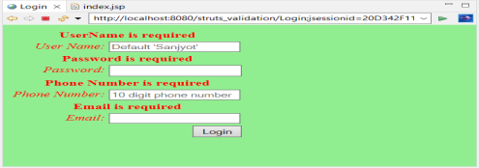
The Phone Number should be 10 digits. If you enter an incorrect phone number, you’ll get the following screen:
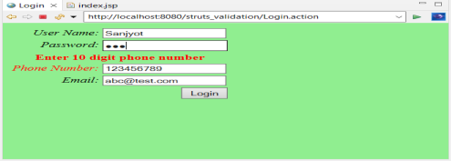
The default User Name is “Sanjyot” and password you can enter anything. After you enter the correct User Name you’ll get the following screen:
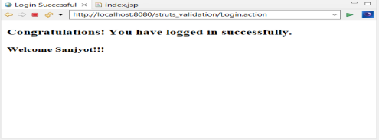

Assignment-IX
User Registration Form Example in AngularJS
Let us go through a step by step process to understand the User Registration in an Angular platform. Following are the salient features of this Registration example.
∙ User Registration form has following basic fields. Form validations can be done in two ways in AngularJS. Click on the respective link to learn in detail. Validations using ngMessages and Angular directives, Properties, attributes
1. Name
2. Email
3. Password
4. Phone
∙ The form will have a hyperlink(top-right corner) to see a list of users which will list all the registered users.
∙ Below the form, you can see a list of registered users with Edit/Delete features enabled. ∙ When the user goes to see the list of users, he can simply click on the Back button to come back to the registration form.
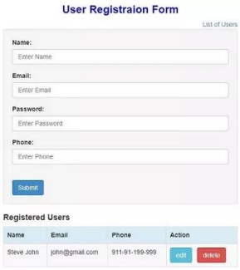
The registration example will have following two pages.
1. Index.html
2. app.js
So let’s begin with UI design. Please take a look at the index page as given below. //Index.html
<!DOCTYPE html>
<html>
<head>
<meta charset="utf-8">
<title>HTML Starter</title>
<meta name="viewport" content="width=device-width, initial-scale=1">
<script
src="https://ajax.googleapis.com/ajax/libs/jquery/1.11.2/jquery.min.js"></script> <script
src="https://ajax.googleapis.com/ajax/libs/angularjs/1.2.26/angular.min.js"></script> <link rel="stylesheet" href="https://maxcdn.bootstrapcdn.com/bootstrap/3.2.0/css/bootstrap.min.css"> <script src="app.js"></script>
</head>
<body>
<div ng-app = "myApp" class = "container" style="width:550px">
<div style="text-align:center;color:blue">
<h3><b>User Registraion Form</b></h3>
</div>
<div ng-controller = "ContactController">
<div align="right">
<a href="#" ng-click="searchUser()">{{title}}</a>
</div>
<form role = "form" class="well" ng-hide="ifSearchUser">
<div class = "form-group">
<label for = "name"> Name: </label>
<input type = "text" id = "name" class = "form-control"
placeholder = "Enter Name " ng-model = "newcontact.name">
</div>
<div class = "form-group">
<label for = "email"> Email: </label>
<input type = "email" id = "email" class = "form-control"
placeholder = "Enter Email " ng-model = "newcontact.email">
</div>
<div class = "form-group">
<label for = "password"> Password: </label>
<input type = "password" id = "password" class = "form
control" placeholder = "Enter Password " ng-model = "newcontact.password"> </div>
<div class = "form-group">
<label for = "phone"> Phone: </label>
<input type = "text" id = "phone" class = "form-control"
placeholder = "Enter Phone " ng-model = "newcontact.phone">
</div>
<br>
<input type="hidden" ng-model="newcontact.id">
<input type="button" class="btn btn-primary" ng
click="saveContact()" class="btn btn-primary" value = "Submit">
</form>
<div><h4><b>Registered Users</b></h4>
<table ng-if="contacts.length" class = "table table-striped table
bordered table-hover">
<thead>
<tr class = "info">
<th>Name</th>
<th>Email</th>
<th>Phone</th>
<th ng-if="!ifSearchUser">Action</th>
</tr>
</thead>
<tbody>
<tr ng-repeat = "contact in contacts">
<td>{{ contact.name }}</td>
<td>{{ contact.email }}</td>
<td>{{ contact.phone }}</td>
<td ng-if="!ifSearchUser">
<a href="#" ng-click="edit(contact.id)"
role = "button" class = "btn btn-info">edit</a> &nbsp;
<a href="#" ng
click="delete(contact.id)" role = "button" class = "btn btn-danger">delete</a> </td>
</tr>
</tbody>
</table>
<div ng-hide="contacts.length > 0">No Users Found</div>
</div>
</div>
</div>
</body>
</html>
∙ As you can see in the above code, we have a form with four fields: Name, Email, Password which have a hidden field id and a Submit button.
∙ Also, we have a table to display the registered users which will display all fields excepts id and password with Action buttons Edit and Delete for each row.
∙ We have a hyperlink button for displaying all users.
Next, we will see the controller javascript file as given below.
//app.js
var myApp = angular.module("myApp", []);
myApp.service("ContactService" , function(){
var uid = 1;
var contacts = [{
'id' : 0,
'name' : 'Steve John',
'email' : 'john@gmail.com',
'password': 'John123',
'phone' : '911-91-199-999'}];
// Save Service for sving new contact and saving existing edited contact.
this.save = function(contact)
{
if(contact.id == null)
{
contact.id = uid++;
contacts.push(contact);
}
else
{
for(var i in contacts)
{
if(contacts[i].id == contact.id)
{
contacts[i] = contact;
}
}
}
};
// serach for a contact
this.get = function(id)
{
for(var i in contacts )
{
if( contacts[i].id == id)
{
return contacts[i];
}
}
};
//Delete a contact
this.delete = function(id)
{
for(var i in contacts)
{
if(contacts[i].id == id)
{
contacts.splice(i,1);
}
}
};
//Show all contacts
this.list = function()
{
return contacts;
} ;
});
////Controller area .....
myApp.controller("ContactController" , function($scope , ContactService){ console.clear();

$scope.ifSearchUser = false;
$scope.title ="List of Users";

$scope.contacts = ContactService.list();
$scope.saveContact = function()
{
console.log($scope.newcontact);
if($scope.newcontact == null || $scope.newcontact == angular.undefined) return;
ContactService.save($scope.newcontact);
$scope.newcontact = {};
};
$scope.delete = function(id)
{
ContactService.delete(id);
if($scope.newcontact != angular.undefined &&
$scope.newcontact.id == id)
{
$scope.newcontact = {};
}
};
$scope.edit = function(id)
{
$scope.newcontact = angular.copy(ContactService.get(id));
};
$scope.searchUser = function(){
if($scope.title == "List of Users"){
$scope.ifSearchUser=true;
$scope.title = "Back";
}
else
{
$scope.ifSearchUser = false;
$scope.title = "List of Users";
}
};
});
In a single javascript file, we have created one service and one controller together but you can even have both in separate js files and the index page.
You can see in the ContactService, according to our requirement we have 4 functions for listing all the users, get a user based on input id, save and delete and also we are initializing a contacts array to display the same when we run the application.
In ContactController, again we have four functions namely: Save, edit, delete and searchUser. The functions in controller make calls to the functions in service on any action taken in the UI.
1. Initially, when you run an app, the controller will fetch the contacts from service and bind them to the table in UI.
2. To add a new user, the user needs to enter all the details and click on the submit which will call the save function in the controller. This function calls save function in service. 3. To update the existing user details, select a user by clicking on edit action. The details
will be bounded to input fields and click on Submit which follows the same logic as save. 4. To remove a user, select a user and click on delete action which calls delete function controller and followed by delete function in service.
Let us go through the execution of the application.
∙ Initially, when the application is loaded, the form gets displayed. To add a new user, enter all the details as follows and click on the Submit button.
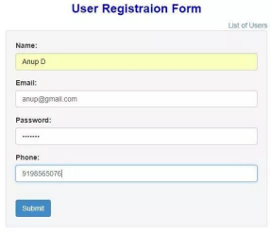
∙ You can see the added users on the registered users’ list as below.
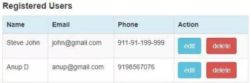
∙ If you want to update a user, you can use the Edit action which will display the current details in form fields as above. You can change the values and click on Submit button to save the latest details. The updated details are displayed in the registered user’s table.
∙ If you want to remove a user from the application, you can use delete action which will erase all the details pertaining to that user and the user row will be deleted from the table. ∙ If you want to see all the users, you can click on the hyperlink ‘List of Users’ on the top right corner of the page. It will take you to the next page where the user details are displayed. Please take a look at below. the Back button on the top-right corner will take you back to the same registration form.
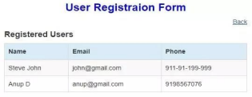

Conclusion:
AngularJS platform is simple and very well designed. It makes every design easy and less coding thus takes less time in development. And we can build our user graphics pages attractive using bootstrap with angularJS.

Assignment-X

Developing Enterprise JavaBeans Applications

This IBM® Redpaper™ publication introduces Enterprise JavaBeans (EJB) and demonstrates by example how to create, maintain, and test EJB components. It explains how to develop session beans and describes the relationships between the session beans and the Java Persistence API (JPA) entity beans. Then, it integrates the EJB with a front-end web application for the sample application. It includes examples for creating, developing, and testing the EJB by using IBM Rational® Application Developer.

The paper is organized into the following sections:
› Introduction to Enterprise JavaBeans
› Developing an EJB module
› Testing the session EJB and the JPA entities
› Invoking EJB from web applications
› More information
The sample code for this paper is in the 4885code\ejb folder.
This paper is intended for developers interested in creating, maintaining, and testing EJB components using IBM Rational Application Developer.

This paper was originally published as a chapter in the IBM Redbooks® publication, Rational Application Developer for WebSphere Software V8 Programming Guide, SG24-7835. The full publication includes working examples that show how to develop applications and achieve the benefits of visual and rapid application development. The publication is available at the following website:
http://www.redbooks.ibm.com/abstracts/sg247835.html?Open

Introduction to Enterprise JavaBeans
EJB is an architecture for server-side, component-based distributed applications written in Java. Details of the EJB 3.1 specification, EJB components and services, and new features in Rational Application Developer are described in the following sections:
› EJB 3.1 specification
› EJB component types
› EJB services and annotations
› EJB 3.1 application packaging
› EJB 3.1 Lite
› EJB 3.1 features in Rational Application Developer

EJB 3.1 specification
The EJB 3.1 specification is defined in Java Specification Request (JSR) 318: Enterprise JavaBeans 3.1. The JPA 2.0 specification and EJB 3.1 specification are separate. The specification of JPA 1.x was included in the EJB 3.0 specification. In this paper we describe the usage of the EJB 3.x specification, with a focus on EJB 3.1.

EJB 3.1 simplified model
Many publications discuss the complexities and differences between the old EJB 2.x programming model and the new EJB 3.x. For this reason, in this paper we focus on the new programming model. To overcome the limitations of the EJB 2.x, the new specification introduces a new simplified model with the following features:
› Entity EJB are now JPA entities, plain old Java objects (POJO) that show regular business interfaces, as plain old Java interface (POJI), and there is no requirement for home interfaces.
› The requirement for specific interfaces and deployment descriptors is removed (deployment descriptor information can be replaced by annotations).
› A new persistence model, which is based on the JPA standard, replaces EJB 2.x entity beans.
› An interceptor facility is used to start user methods at the invocation of business methods or at lifecycle events.
› Default values are used whenever possible (“configuration by exception” approach).
› Requirements for the use of checked exceptions are reduced.
› EJB 3.1 Lite, as a minimal subset of the full EJB 3.1 API, offers the major functions of EJB
3.1 API.
2 Developing Enterprise JavaBeans Applications
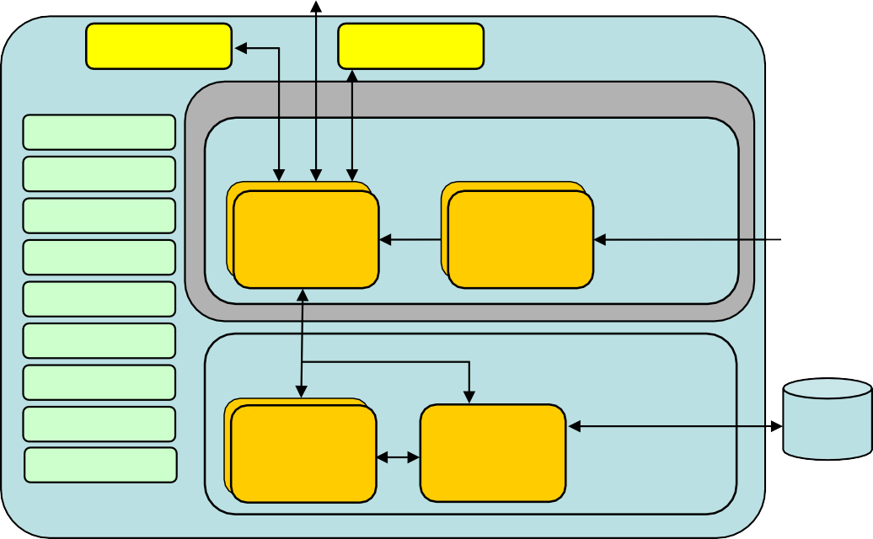
Figure 1 shows how the model of Java 2 Platform, Enterprise Edition (J2EE) 1.4 has been reworked with the introduction of the EJB 3.x specification. With the EJB 3.1 specification, this model was updated with new features. The new features are summarized in “EJB 3.1 features in Rational Application Developer” on page 20.
Remote Client
Local Client
Remote Client
Application Server

EJB Container
JMS
JTA Business Logic Tier
JNDI JDBC RMI-IIOP
Threading Pooling Security
Web Services
JMS
Provider
SessiionBBeeaanns
DriMessage s
Message
DrviveennBBeeaanns
Persistency Tier
MesJsPaAge DrivEentBitiesns
Entity Manager
RDBMS
Figure 1 EJB 3.1 architecture

EJB component types
EJB 3.1 has the following component types of EJB:
› Session beans: stateless
› Session beans: stateful
› Session beans: Singleton bean
› Message-driven EJB (MDB) This section defines several EJB.

Session beans
There are several kinds of session beans, the stateless and stateful EJB, and as a new feature, the definition of Singleton session beans. In this section, we describe these tasks:
› Defining a stateless session bean in EJB 3.1
› Defining a stateful session bean in EJB 3.1
› Defining a Singleton session bean in EJB 3.1

Additionally, we show the lifecycle events and leading practices for developing session beans.

Defining a stateless session bean in EJB 3.1
Stateless session EJB are always used to model a task that is performed for client code that invokes it. They implement the business logic or rules of a system, and provide the

Developing Enterprise JavaBeans Applications

coordination of those activities between beans, such as a banking service that allows for a transfer between accounts.

A stateless session bean is generally used for business logic that spans a single request and therefore cannot retain the client-specific state among calls.

Because a stateless session bean does not maintain a conversational state, all the data exchanged between the client and the EJB is passed either as input parameters, or as a return value, declared on the business method interface.
To declare a session stateless bean, add the @Stateless annotation to a POJO, as shown in Example 1.

Example 1 Definition of a stateless session bean

@Stateless
public class MyFirstSessionBean implements MyBusinessInterface {

// business methods according to MyBusinessInterface
.....
}

Note the following points in Example 1:
› MyFirstSessionBean is a POJO that shows a POJI, in this case, MyBusinessInterface. This interface is available to clients to invoke the EJB business methods. For EJB 3.1, a business interface is not required.
› The @Stateless annotation indicates to the container that the bean is a stateless session bean so that the appropriate lifecycle and runtime semantics can be enforced.
› By default, this session bean is accessed through a local interface.

This information is all that you need to set up a session EJB. There are no special classes to extend and no interfaces to implement.

Figure 2 shows the simple model of EJB 3.1.

MyBusinessInterface

Implements
MyFirstSessionBean
Figure 2 EJB is a POJO exposing a POJI

If we want to show the same bean on the remote interface, we use the @Remote annotation, as shown in Example 2 on page 5

4 Developing Enterprise JavaBeans Applications

Example 2 Defining a remote interface for stateless session bean

@Remote(MyRemoteBusinessInterface.class)
@Stateless
public class MyBean implements MyRemoteBusinessInterface {
// ejb methods
.....
}
Tip: If the session bean implements only one interface, you can use the @Remote
annotation without a class name.

Defining a stateful session bean in EJB 3.1
Stateful session EJB are typically used to model a task or business process that spans multiple client requests. Therefore, a stateful session bean retains its state on behalf of an individual client. The client stores the handling of the stateful EJB, so that it always accesses the same EJB instance. By using the same approach that we adopted before, to define a stateful session EJB, you must declare a POJO with the annotation @Stateful, as shown in Example 3.

Example 3 Defining a stateful session bean

@Stateful
public class SecondSessionBean implements MyBusinessStatefulInterface {
// ejb methods
.....
}
The @Stateful annotation indicates to the container that the bean is a stateful session bean so that the appropriate lifecycle and runtime semantics can be enforced.

Defining a Singleton session bean in EJB 3.1
The definition of a Singleton session bean is a new feature of EJB 3.1. The definition of the Singleton pattern is associated with the defined design pattern in software engineering. You define a session bean as a Singleton to restrict the instantiation of this class to only one object. For example, the object, which coordinates actions across the system, can be defined as a Singleton, because only this object is responsible for the coordination. Therefore, you define the annotation @Singleton in front of the class declaration, as shown in Example 4.
The new annotation @LocalBean is described in “Business interfaces” on page 6.
Example 4 Defining a Singleton session bean

@Startup @Singleton @LocalBean
public class MySingletonBean{

// ejb methods
.....
}

A Singleton session bean offers you the opportunity to initialize objects at application start-up. This function can replace proprietary IBM WebSphere® Application Server start-up beans. Therefore, you also define the new annotation @Startup in front of the class declaration, as
shown in Example 4 on page 5. As result, you have the initialization at the application start-up instead of the first invocation by the client code.

The concurrency in Singleton session beans is either defined as container-managed concurrency (CMC) or bean-managed concurrency (BMC). In case no annotation for the concurrency is specified in front of the class, the default value is CMC. The further default value for CMC is @Lock(WRITE). If you want to define a class or method associated with a shared lock, use the annotation @Lock(READ).
To define BMC, use the annotation @ConcurrencyManagement (ConcurrencyManagementType.BEAN). After it is defined as BMC, the container allows full concurrent access to the Singleton session bean. Furthermore, you can define that concurrency is not allowed. Therefore, use the annotation @ConcurrencyManagement (ConcurrencyManagementType.CONCURRENCY_NOT_ALLOWED).
For detailed information about Singleton session beans, see section 3.4.7.3 “Singleton Session Beans” in JSR 318: Enterprise JavaBeans 3.1.

Business interfaces
EJB can show various business interfaces, because the EJB can be accessed from either a local or remote client. Therefore, place common behavior to both local and remote interfaces in a superinterface, as shown in Figure 3.

You must ensure the following aspects:
› A business interface cannot be a local and a remote business interface of the bean.
› If a bean class implements a single interface, that interface is assumed to be the business interface of the bean. This business interface is a local interface, unless the interface is designated as a remote business interface by use of the @Remote annotation or with the deployment descriptor.

This approach provides flexibility during the design phase, because you can decide which methods are visible to local and remote clients.
MyAbstractBusinessInterface
Extends
MyLocalBusinessInterface
MyRemoteBusinessInterface
Implements
MyFirstSessionBean

Assignment-XI
Mini Project: Design and implement a dynamic web application for any business functionality by using web development technologies that you have learnt in the above given assignments

